LeetCode--SQL笔试题目

# 第175题. Combine Two Tables

## 题目介绍

考查知识点：**外连接查询：outer join... on...**

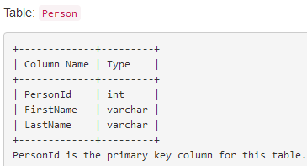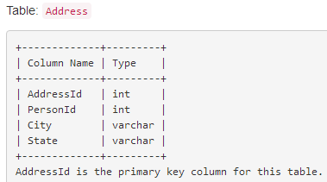

Write a SQL query for a report that provides the following information for each person in the Person table, **regardless if there is an address for each of those people**:

FirstName, LastName, City, State

# Write your MySQL query statement below

# My answer is : (Right)

**select p.FirstName,p.LastName,a.City,a.State**

**from Person p left join Address a**

**on p.PersonId = a.PersonId;**

**Algorithm**

Since the PersonId in table **Address** is the foreign key of table **Person**, we can join this two table to get the address information of a person.

**Considering there might not be an address information for every person, we should use outer join instead of the default inner join.**

**必须使用外连接，不能使用默认的内连接。**

## MySQL：参考答案

select FirstName, LastName, City, State

from Person left join Address

on Person.PersonId = Address.PersonId;

Note: Using where clause to filter the records will fail if there is no address information for a person because it will not display the name information.

# 第176题. Second Highest Salary

## 题目介绍

Write a SQL query to get the second highest salary from the Employee table.

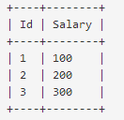

For example, given the above Employee table, the query should return 200 as the second highest salary. If there is no second highest salary, then the query should return null.

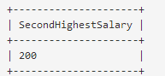

分析：（1） **取别名**，利用as，as可省略；

（2）**降序排序**：order by Salary desc；

（3）**筛选第二值**：利用limit [offset,] num筛选第二个Salary值。

（4）**去重处理**：利用distinct实现去重，工资相同去除；

（5）**NULL处理**：只有一条数据或所有人工资都相同，如何处理，利用IFNULL函数处理。

## 答案：

# Write your MySQL query statement below

**# The First Answer：**

**select IFNULL((select distinct Salary from Employee**

**order by Salary desc limit 1,1),NULL)**

**as SecondHighestSalary;**

# The Second Answer：

**# select (select distinct Salary from Employee**

**# order by Salary desc limit 1,1)**

**# as SecondHighestSalary;**

## 答案分析：

**Algorithm**

Sort the distinct salary in descend order and then utilize the [LIMIT](https://dev.mysql.com/doc/refman/5.7/en/select.html) clause to get the second highest salary.

SELECT **DISTINCT** Salary **AS SecondHighestSalary**

FROM Employee ORDER BY Salary DESC LIMIT 1 OFFSET 1

However, this solution will be judged as 'Wrong Answer' if there is no such second highest salary since there might be only one record in this table. To overcome this issue, we can take this as a temp table.

参考答案：

**SELECT (SELECT DISTINCT Salary FROM Employee ORDER BY Salary DESC LIMIT 1 OFFSET 1) AS SecondHighestSalary**;

Another way to solve the 'NULL' problem is to use IFNULL funtion as below.

**SELECT IFNULL((SELECT DISTINCT Salary FROM Employee ORDER BY Salary DESC LIMIT 1 OFFSET 1),NULL) AS SecondHighestSalary**

对于NULL的处理说明：不存在的，mysql返回的是空即Empty set，所以需要人为指定为NULL。**解决方法：再在外面嵌套一个select语句，即可返回NULL**，还可以再利用IFNULL更加明确的指明更好。



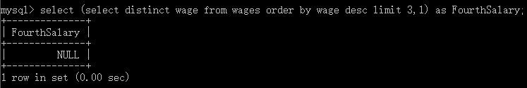

# 子查询、连接查询—网易

## 题目介绍

年级成绩表，四个字段id、class、name、score，写出一条SQL语句查询出每个班级的成绩最高同学的记录，并按照班级顺序列出。

select * from grade_scores;

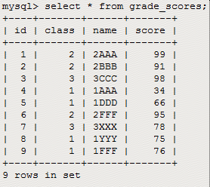

## SQL语句

思路分析：需要每个班级的最高分，显然需要group by分组；最高分利用MAX函数实现；

子查询：首先根据分组查询获取到每个班级的最高分和班级号，当成一个新的表格，与原表进行连接查询。

select **class,MAX(score)** score from grade_scores group by class;

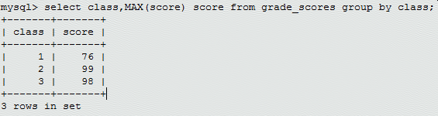

说明：MAX函数会选择出每组中分数最高的记录。

select s.id,s.class,s.name,s.score from grade_scores s join (select class,MAX(score) **score** from grade_scores group by class) n on s.class = n.class and s.score = n.score order by class asc;

